|  |  |  |  |
| --- | --- | --- | --- |
|  | | | |
| **Expt. No:** | | **1** | **Introduction to Multisim** |
|  | | |
| **Date:** | **13-08-2020** | |
|  | | | |

**Aim:**  To study the Multisim software interface and the tools thereby get acquainted with implementing and simulating circuits using Multisim Live Simulator.

**SOFTWARE TOOLS / OTHER REQUIREMENTS:**

1. Multisim Live (Online Interface)

# working on multisim live simulator:

NI Multisim (formerly MultiSIM) is an electronic [schematic capture](https://en.wikipedia.org/wiki/Schematic_capture) and simulation program which is part of a [suite](https://en.wikipedia.org/wiki/Software_suite) of circuit design programs, along with [NI Ultiboard](https://en.wikipedia.org/wiki/NI_Ultiboard). Multisim is one of the few circuit design programs to employ the original [Berkeley](https://en.wikipedia.org/wiki/University_of_California,_Berkeley) [SPICE](https://en.wikipedia.org/wiki/SPICE) based software simulation. Multisim was originally created by a company named [Electronics Workbench](https://en.wikipedia.org/wiki/National_Instruments#Electronics_Workbench_Group), which is now a division of [National Instruments](https://en.wikipedia.org/wiki/National_Instruments). Multisim includes microcontroller simulation (formerly known as MultiMCU), as well as integrated import and export features to the [printed circuit board](https://en.wikipedia.org/wiki/Printed_circuit_board) layout software in the suite, [NI Ultiboard](https://en.wikipedia.org/wiki/NI_Ultiboard). Multisim is widely used in academia and industry for circuits education, electronic schematic design and SPICE simulation.

Multisim Live is a free online circuit simulator that includes SPICE software, which lets you create, learn and share electronics circuits online.

**Creating Circuits on Multisim:**



**Placing Voltage Source:**

Tap the Source subpalette and tap AC Voltage and tap on the workspace or Type V if you are using a device with a keyboard, and tap to place the source.

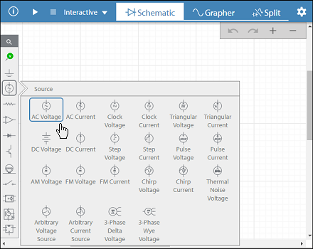

**Placing Resistor:**

Place a resistor by dragging from the Passive subpalette or Type R if you are using a device with a keyboard, and tap to place the resistor.

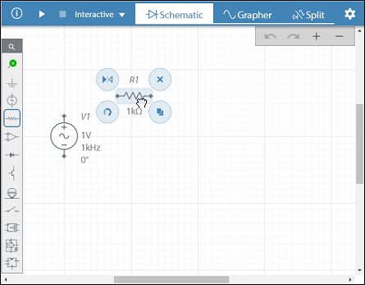

**Placing Capacitor:**

Type C if you are using a device with a keyboard, and tap to place the capacitor.

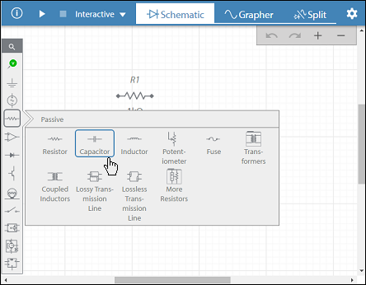

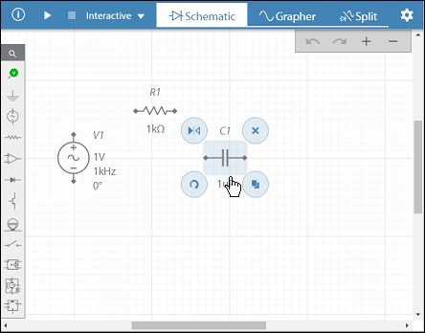

**Rotating Components:**

Tap rotate 90 clockwise small to rotate the capacitor and other components.

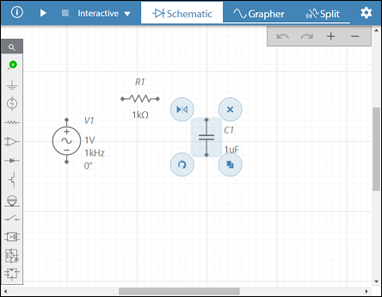

**Wiring the components:**

Tap a component's wiring point (black diamond) and tap another wiring point. The connection is automatically made, and the new wire is selected.

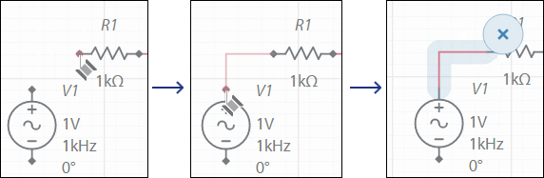

**Saving the design:**

Tap navigation small in the title bar and select Save as.

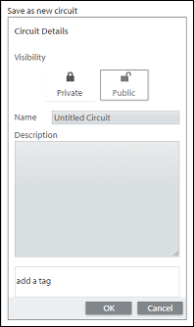

**Simulating a Design:**

To run a simulation, you must place at least one probe.

1. Drag a voltage probe from the palette and place as shown below.

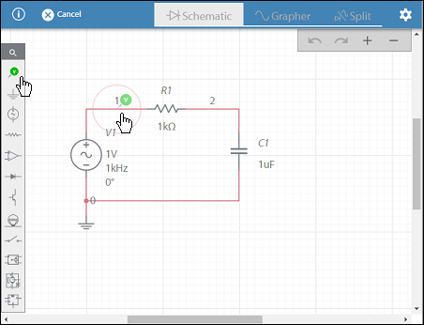

1. Place a second probe.

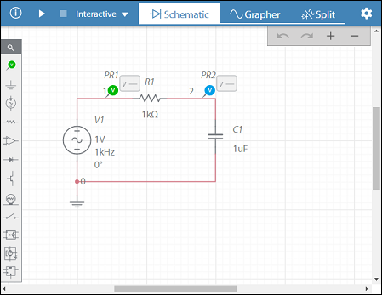

**Select and run simulation**

1. Select Transient from the toolbar.

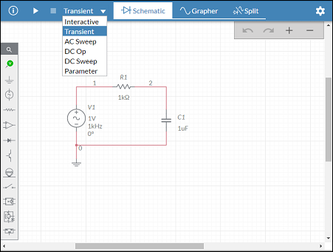

1. Tap run button in the toolbar. For transient simulation, the view switches to the [grapher](https://www.multisim.com/help/simulation/grapher/).
2. Tap configuration button in the toolbar to open the configuration pane. You can also double-tap on the grapher.
3. Use the Plots and Axes sections to manipulate the grapher as desired.

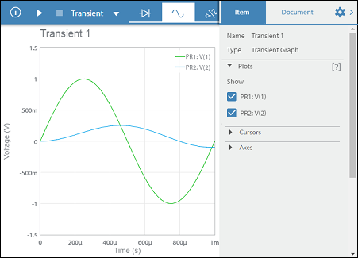

1. Switch the simulation type to AC Sweep and tap run button.

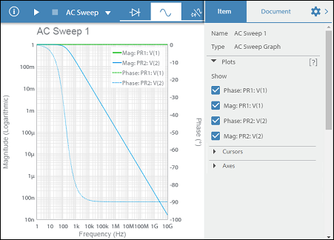

**Simulating a simple Digital Circuit:**

**Step 1: Selecting AND Gate**

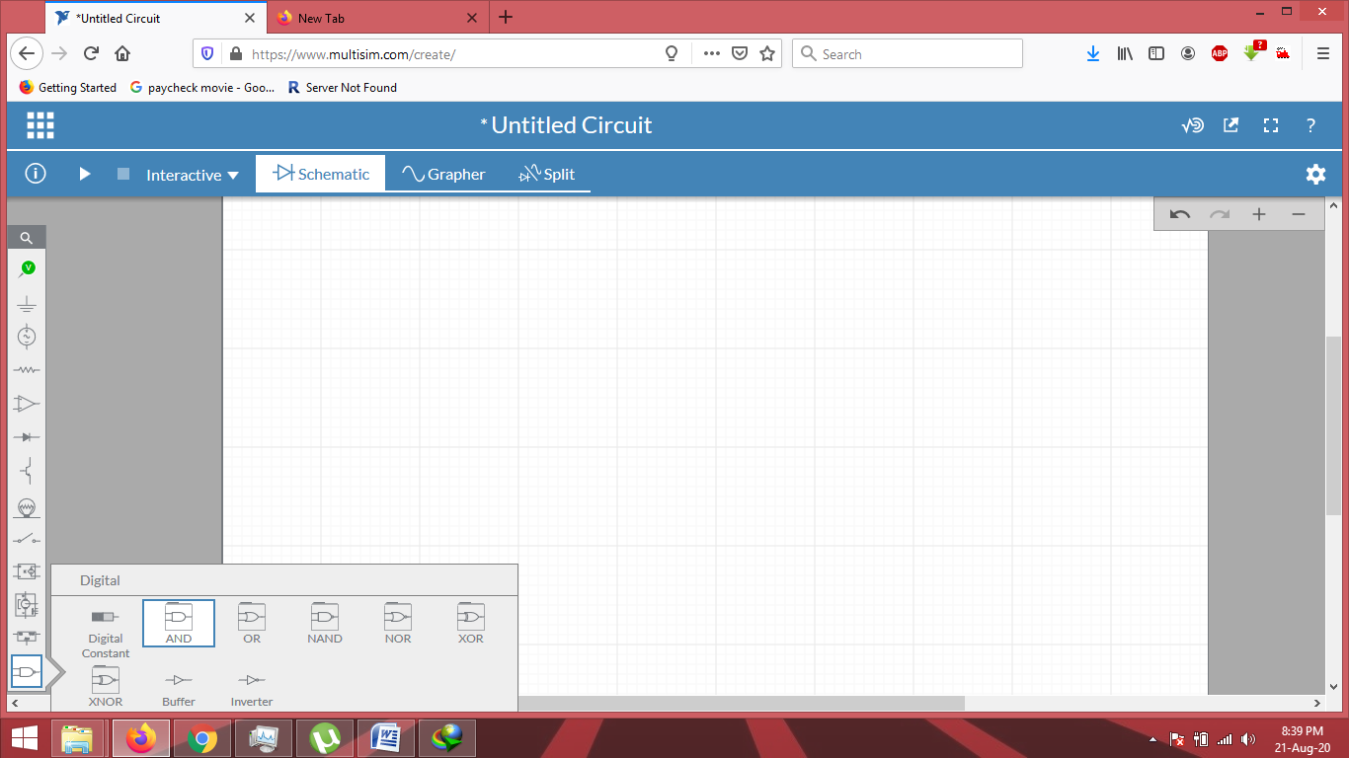

**Step 2: Adding Source (Clock Voltages)**

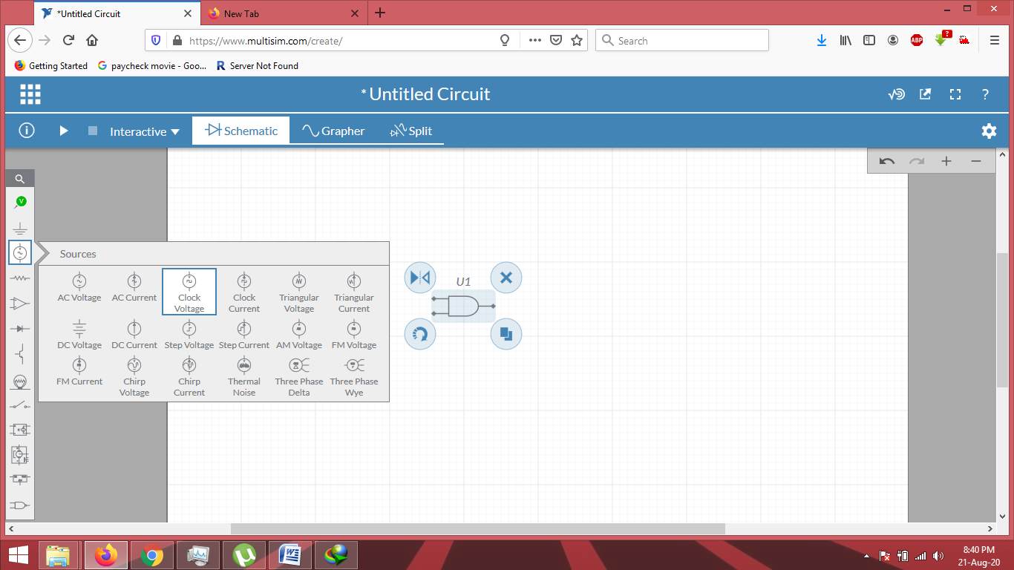

**Step 3: Adding Load (LED)**

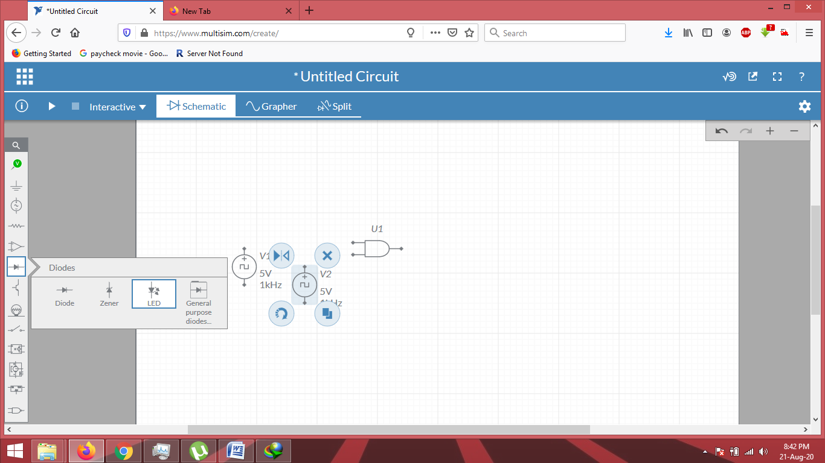

**Step 4: Grounding the Components:**

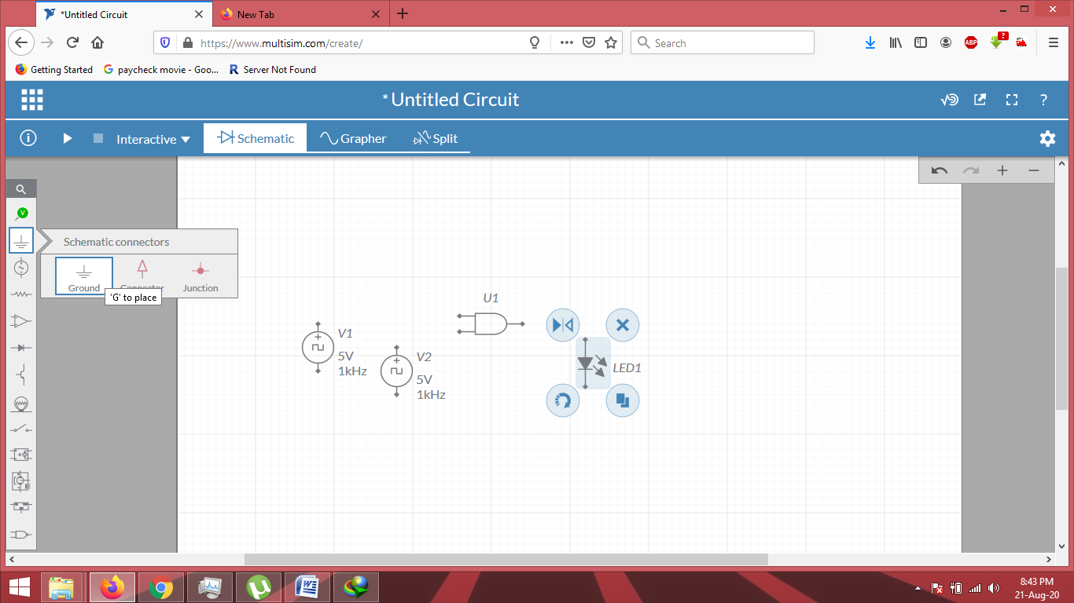

**Step 5: Connecting Components**

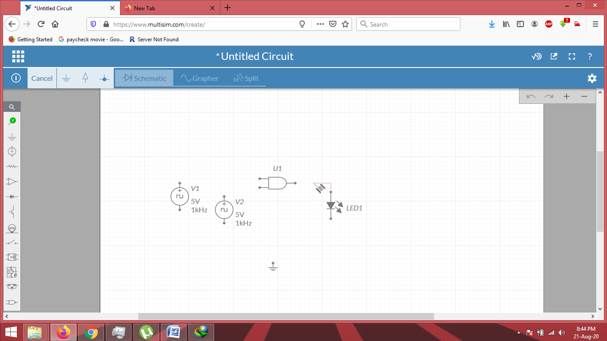

**Step 6: Adding Probes**

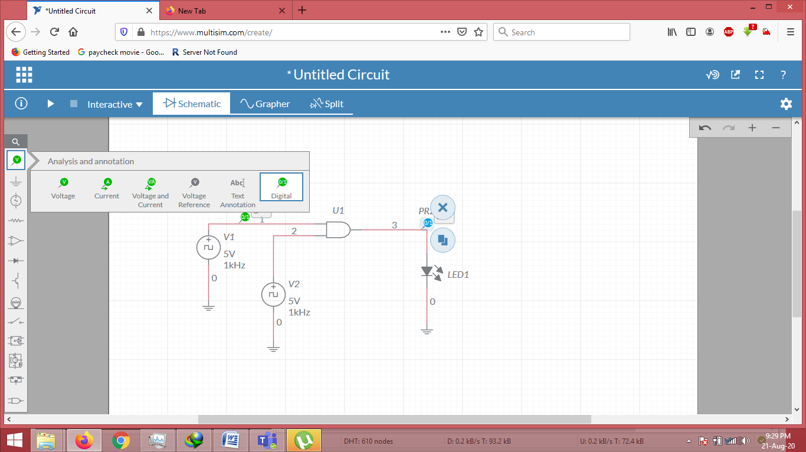

**Step 7: Finally we Simulate the Design**

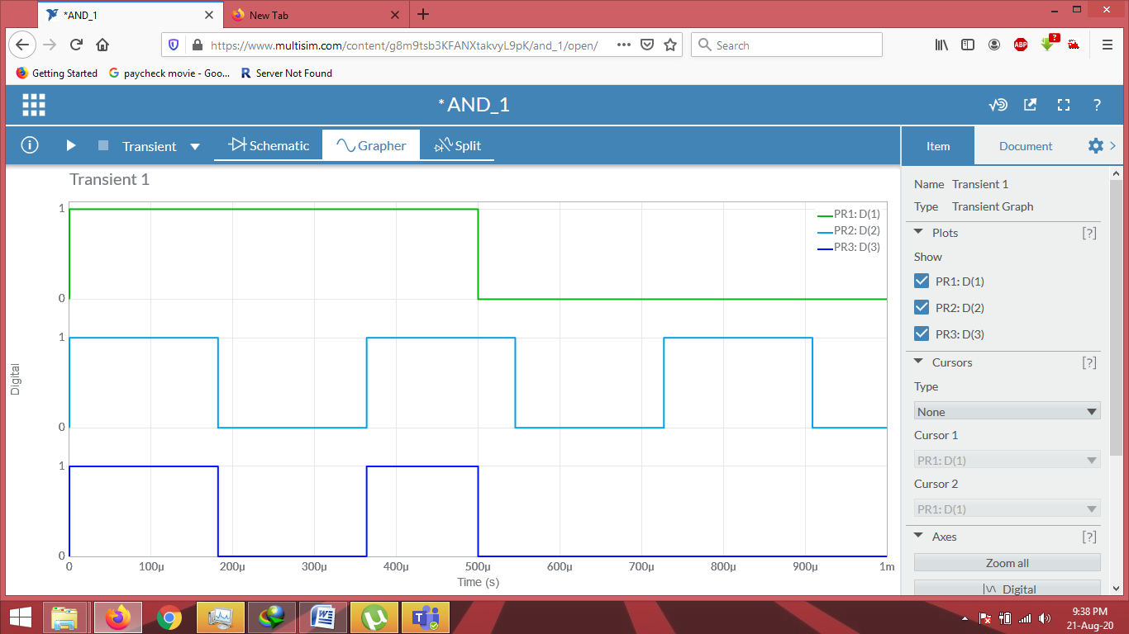

**Step 8: Exporting Schematic/Grapher Images/Screenshots**

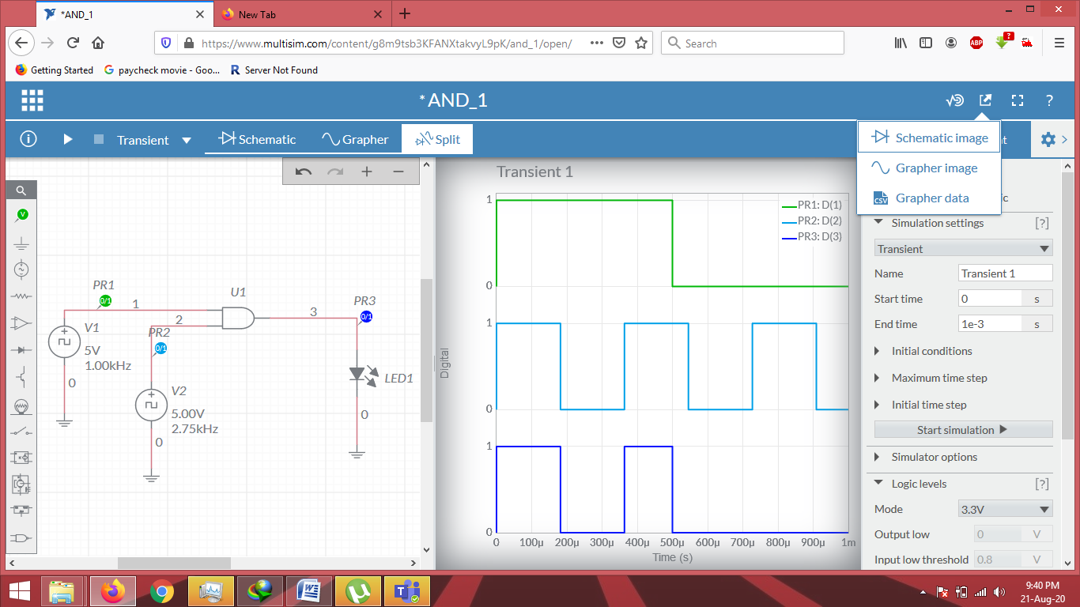

**Conclusions:**

1.) We learned and Implemented *Multisim Software interface* and used different electronic tools available in the simulator to create circuits.

2.) We used *resistor, wires, D.C. voltage source, Voltmeter, Ammeter* and other electronic devices to **verify** *current and voltage* across resistor by *theoretical* and simulated data with Multisim values obtained.

3.) We also learned how to Export Schematic Image, grapher Image and its Data from Multisim.

**Assignment –1 Q1**

*a.) Implement the circuit as shown in Figure in Multisim online.*

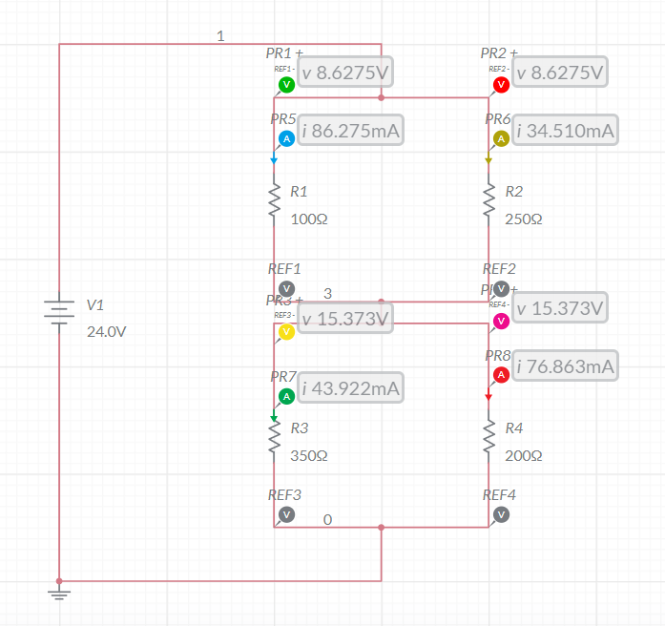

*b.) Evaluate the current and voltage across each resistor using simulator.*

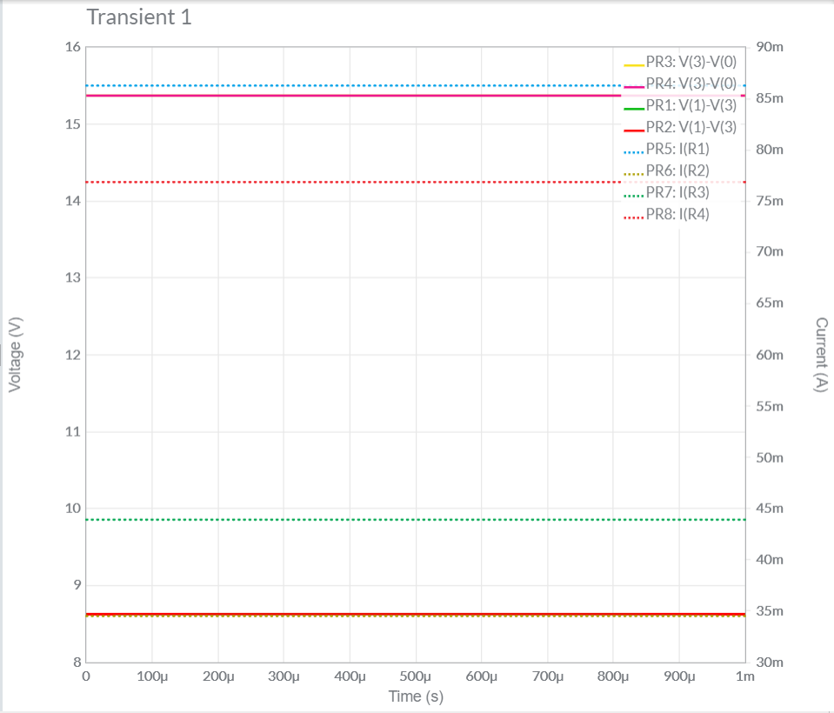

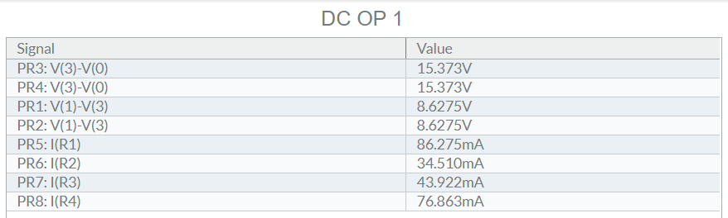

*c.) Compare with theoretical values.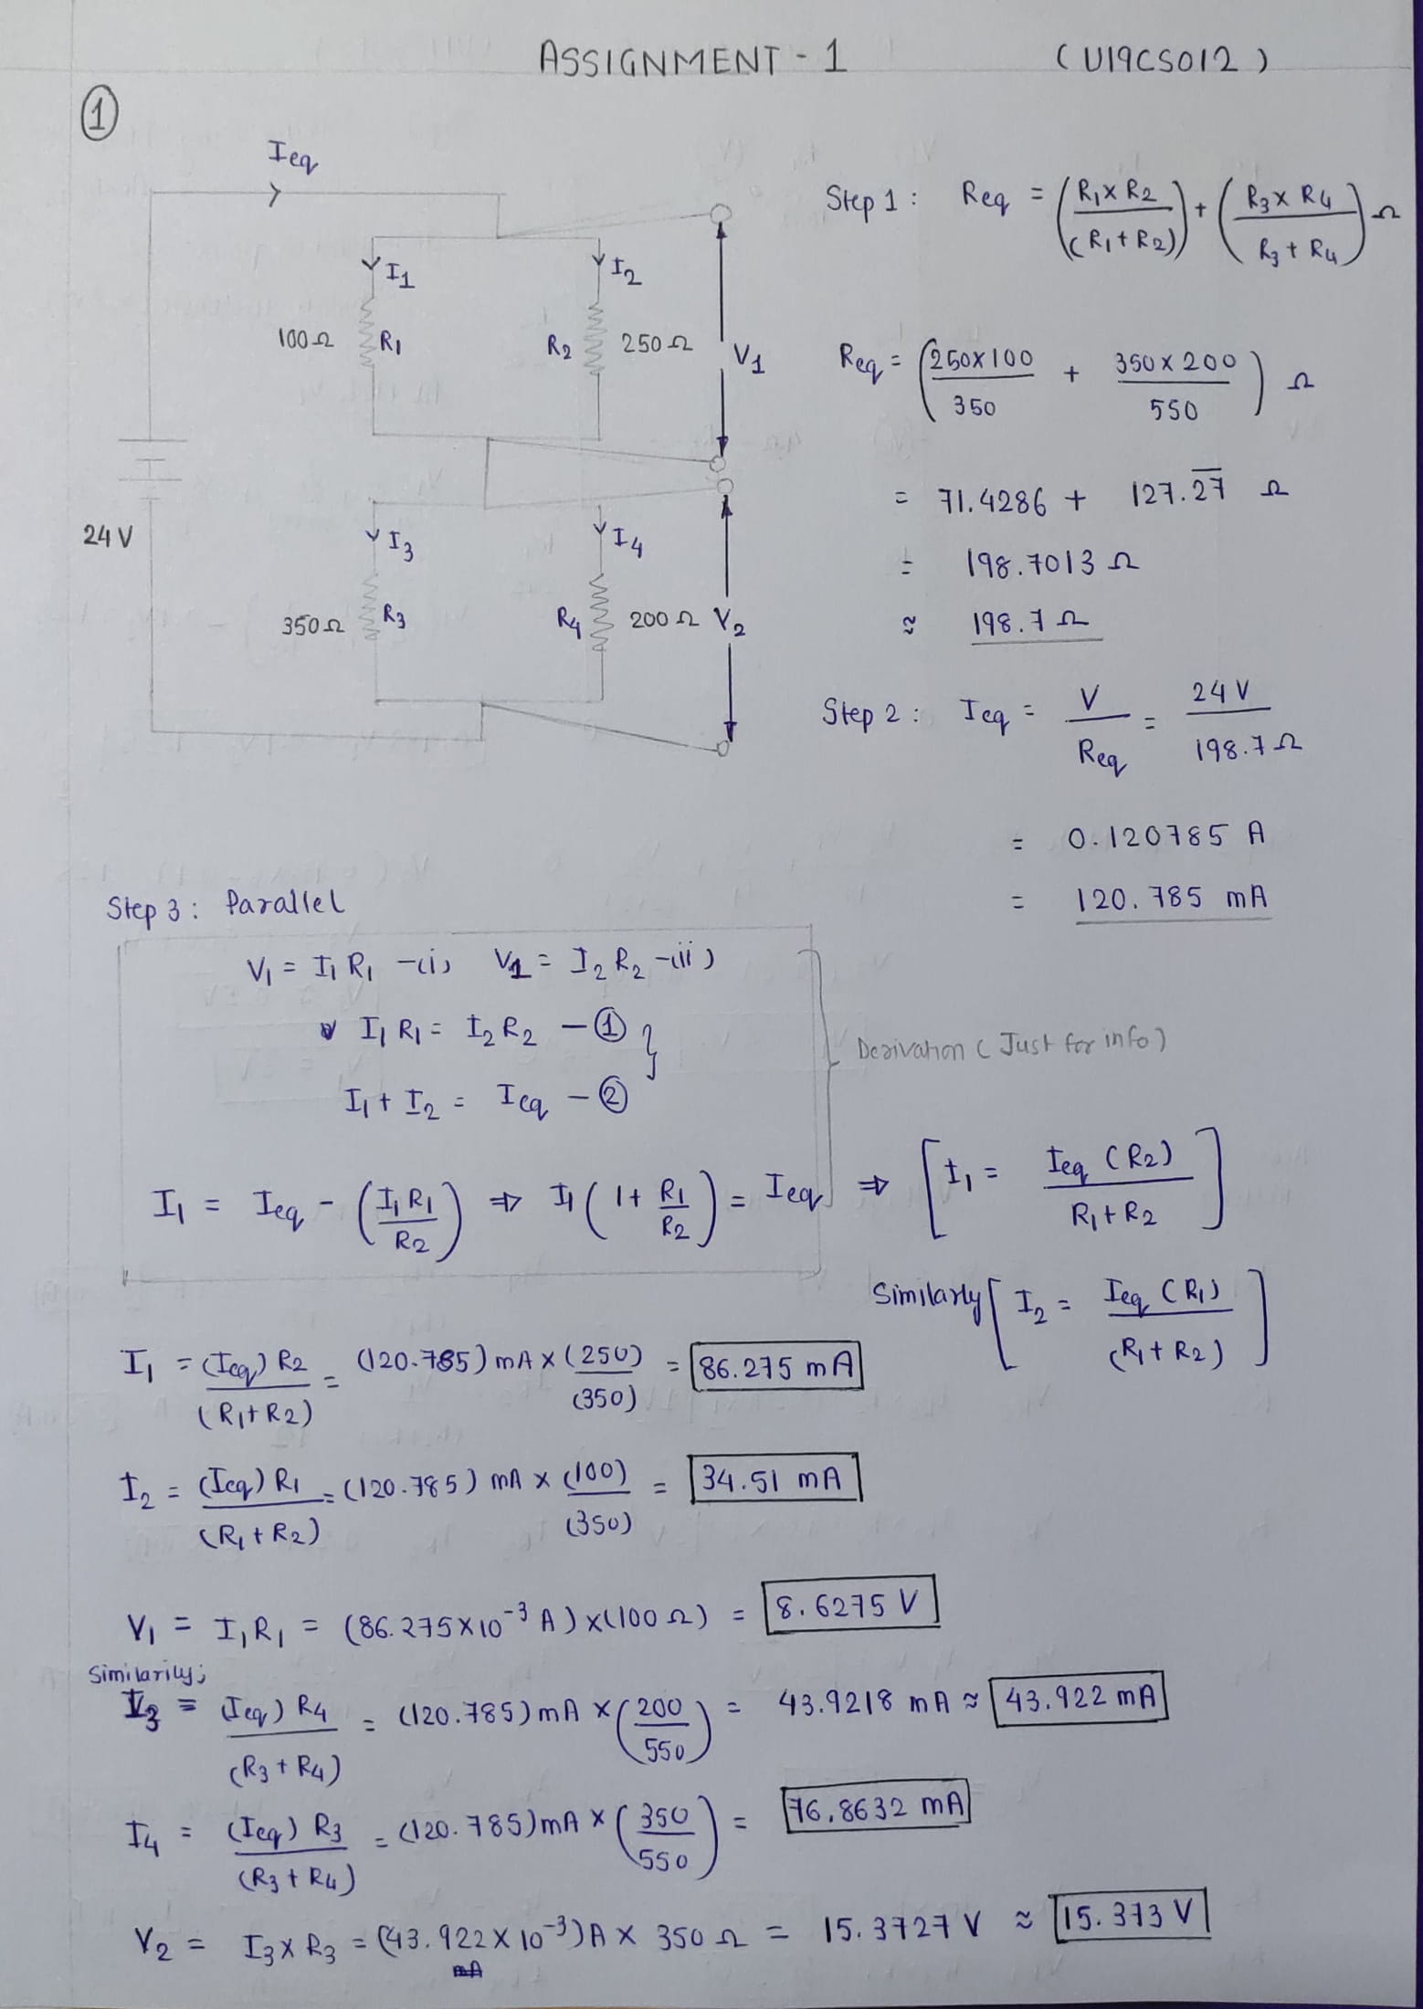*

*d.) Final Result and Conclusion*

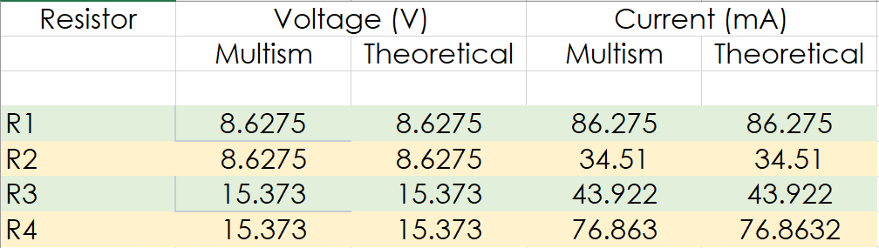

*Conclusion:*

We can observe from Above Table, Both the *Theoretical* and *Multisim* Values of Current and Voltage are **Equal**.

Hence, Experiment is Performed Successfully (without any Error).

**Assignment –1 Q2**

*a.) Implement the circuit as shown in Figure in Multisim online.*

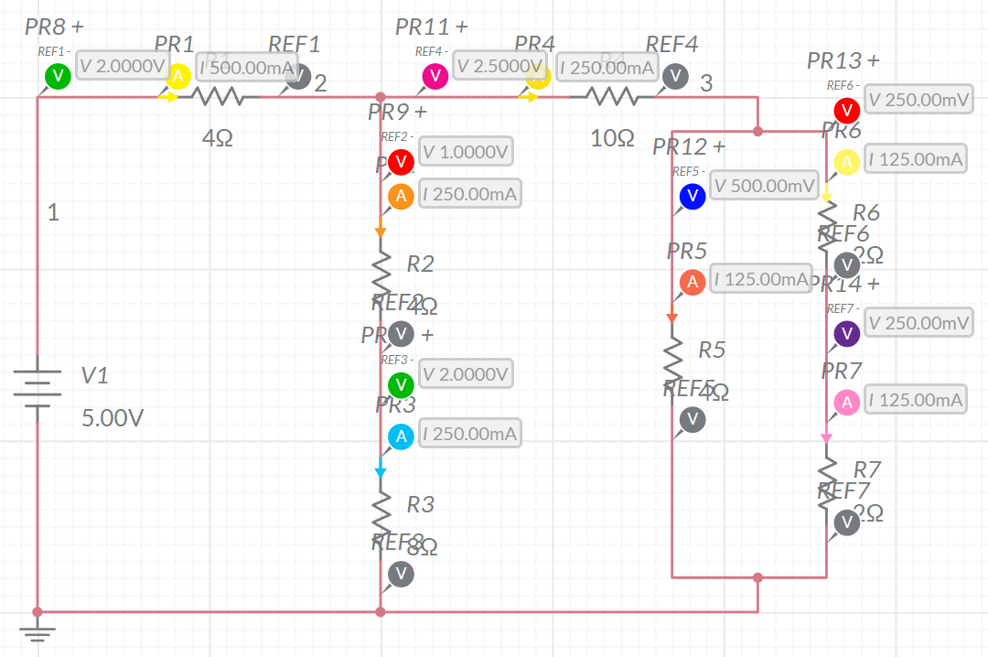

*b.) Evaluate the current and voltage across each resistor using simulator.*

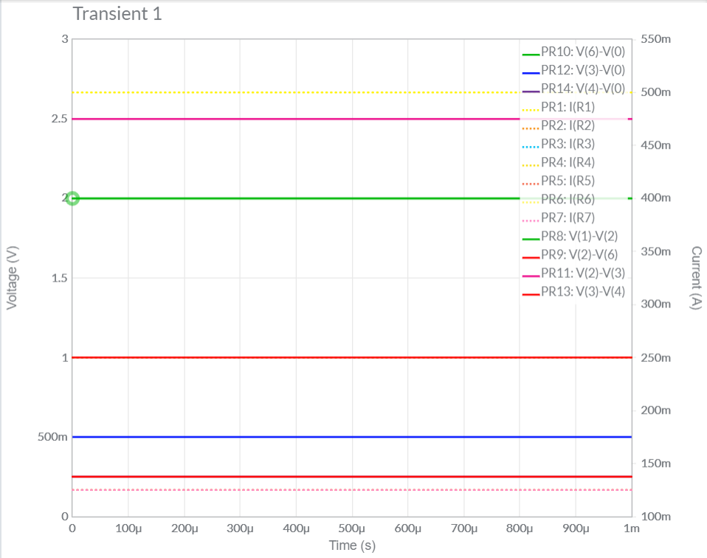

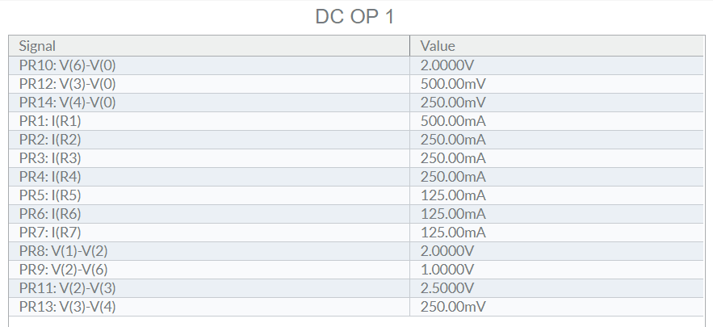

*c.) Compare with theoretical values.*

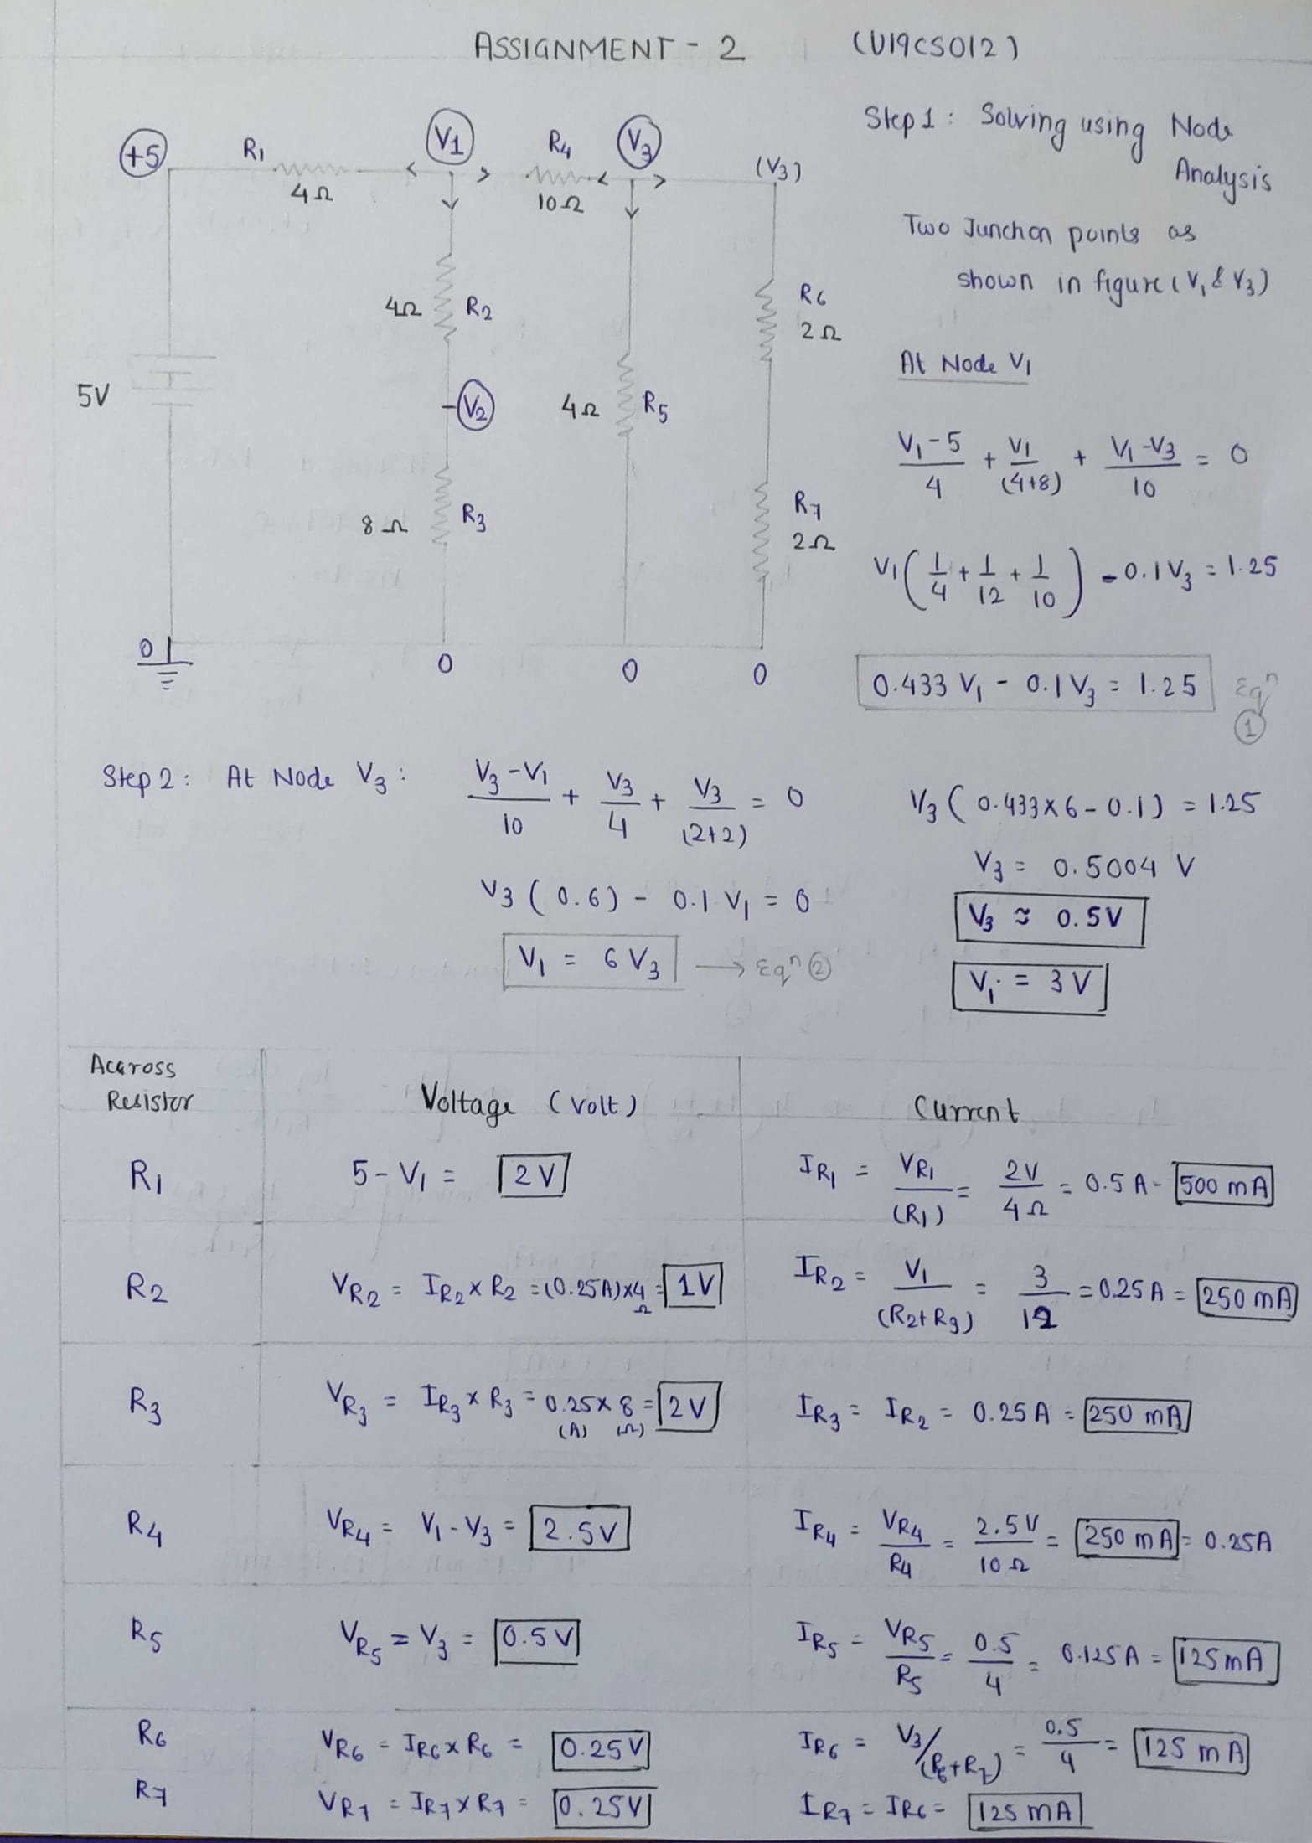

*d.) Final Result and Conclusion*

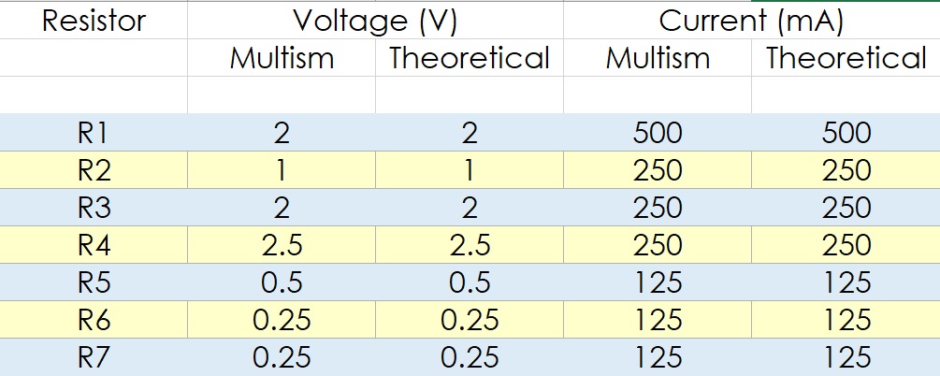

*Conclusion:*

We can observe from Above Table, Both the *Theoretical* and *Multisim* Values of Current and Voltage are **Equal**.

Hence, Experiment is Performed Successfully (without any Error).